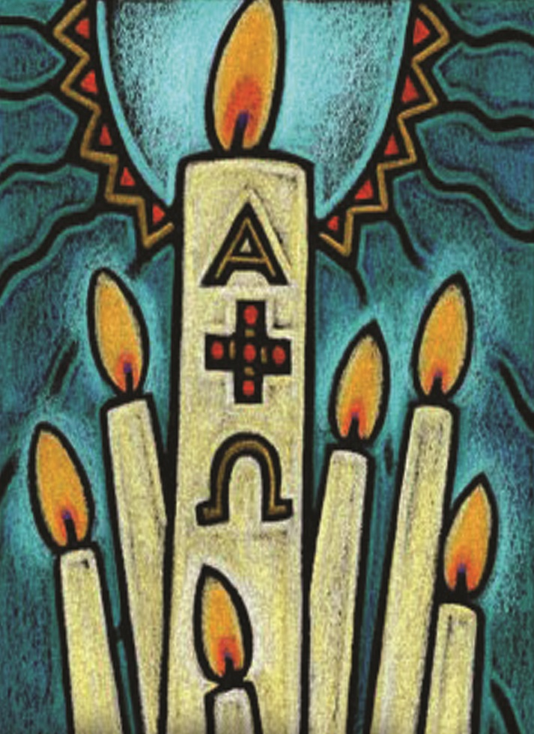
THE
GREAT VIGIL
OF EASTER
April 8, 2023
Easter Vigil (Holy Saturday)

SERVICE OF LIGHT                             
(Service Note: We see the first hope of the Resurrection as the Paschal (Easter) candle is lit and we give thanks to God for Jesus who is the Light of the World.)

INVOCATION

P In the name of the Father and of the T Son and of the Holy Spirit.
C Amen.

P Beloved in the Lord, on this most holy night, in which our Lord Jesus passed over from death to life, we are gathered here in vigil and prayer. This is the Passover of the Lord in which, by hearing His Word and celebrating His Sacraments, we share in His victory over death.

P Let us pray. O God, You are like a refiner’s fire, and Your Spirit enkindles the hearts of Your faithful people with the fire of Your love. Bless, we implore You, this new flame and those who keep this joyful Easter festival, that burning with desire for life with You, we may be found rightly prepared to share in the Feast of Light which has no end; through Jesus Christ, Your Son, our Lord, who lives and reigns with You and the Holy Spirit, one God, now and forever.
C Amen.

BLESSING OF THE PASCHAL CANDLE

P Christ Jesus, the same yesterday, today, and forever, the beginning and the ending, the Alpha and the Omega. His are time and eternity; His are the glory and dominion, now and forever. By His wounds we have healing both now and forever. Amen.

The paschal candle is lit.

P May the light of Christ, who is risen in glory from the dead, scatter all the darkness of our hearts and minds.

COLLECT

P Let us pray. Almighty and most merciful God, pour out on us Your abundant blessing that all who in true faith share this night in joyful celebration of the resurrection of our Lord Jesus Christ from the dead may be filled with Your heavenly benediction. Once we were in darkness, but now we are in the light, even Jesus Christ, our Lord.
C Amen.

All light their candles from the paschal candle and follow the candle bearer
in procession into the darkened church.

The bearer of the paschal candle stops at the entrance to the nave.

LUX CHRISTI

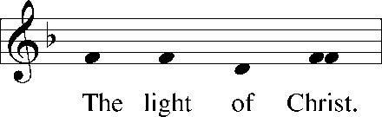
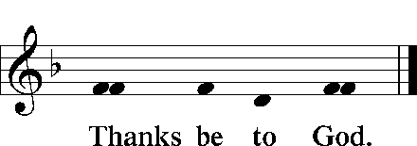

The bearer of the paschal candle stops in the middle of the nave.
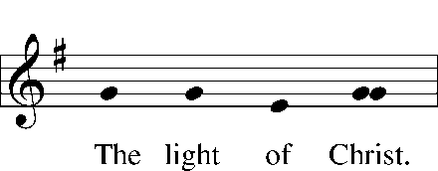
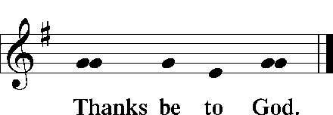

When all have processed, the bearer of the paschal candle lifts the paschal candle high.
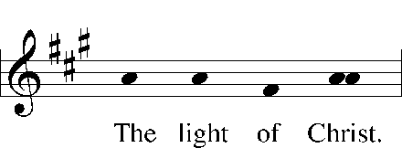
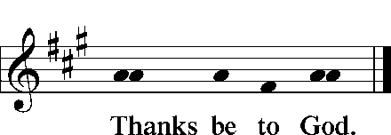

EXSULTET

P Rejoice now, all you heavenly choirs of angels; rejoice now, all creation; sound forth, trumpet of salvation, and proclaim the triumph of our King. Rejoice, too, all the earth, in the radiance of the light now poured upon you and made brilliant by the brightness of the everlasting King; know that the ancient darkness has been forever banished. Rejoice, O Church of Christ, clothed in the brightness of this light; let all this house of God ring out with rejoicing, with the praises of all God’s faithful people.

P The Lord be with you.
C And also with you.

P Lift up your hearts.
C We lift them to the Lord.

P Let us give thanks to the Lord our God.
C It is right to give Him thanks and praise.

P It is truly good, right, and salutary that we should at all times and in all places, with all our heart and mind and voice, praise You, O Lord, Holy Father, almighty everlasting God, and Your only-begotten Son, Jesus Christ. For He is the very Paschal Lamb who offered Himself for the sin of the world, who has cleansed us by the shedding of His precious blood. This is the night when You brought our fathers, the children of Israel, out of bondage in Egypt and led them through the Red Sea on dry ground. This is the night when all who believe in Christ are delivered from bondage to sin and are restored to life and immortality. This is the night when Christ, the life, arose from the dead. The seal of the grave is broken and the morning of the new creation breaks forth out of night. Oh, how wonderful and beyond all telling is Your mercy toward us, O God, that to redeem a slave You gave Your Son. How holy is this night when all wickedness is put to flight and sin is washed away. How holy is this night when innocence is restored to the fallen and joy is given to those downcast. How blessed is the night when man is reconciled to God in Christ. Holy Father, accept now the evening sacrifices of our thanksgiving and praise. Let Christ, the true light and morning star, shine in our hearts, He who gives light to all creation, who lives and reigns with You and the Holy Spirit, one God, now and forever.
C Amen.

All extinguish their candles.

Sit

SERVICE OF READINGS                          
(Service Note: The readings from the Old Testament tell the story of God’s Redemption of His people, we understand this truth: We know God by what He has done.)

P In this most holy night, our Savior, Christ the Lord, broke the power of death and by His resurrection brought life and salvation to all creation. Let us praise the Lord, for He truly keeps His word. The Sun of Righteousness has dawned upon us who have sat in darkness and in the shadow of death.

THE CREATION Genesis 1:1-2:3; 3:1-24

P This is the Word of the Lord.
C Thanks be to God.

P Let us pray. Almighty God, through Your Word and Spirit You most wonderfully created all things, and through the Word made flesh You brought new life to fallen humanity. Grant that in Your mercy we may be conformed to the image of Him who shares fully in our humanity, even Jesus Christ, our Lord.
C Amen.
THE FLOOD Genesis 7:1–5, 11–18; 8:6–18; 9:8–13

P This is the Word of the Lord.
C Thanks be to God.

P Let us pray. O Lord, You kill and You raise to life; You brought the flood upon a wicked and perverse generation, and yet You saved faithful Noah and his family in the ark. Keep us in safety in the ark of Christ’s body, the Church, that Your mercy may come to its fullness and Your salvation be preached to the ends of the earth; through Jesus Christ, our Lord.
C Amen.

ISRAEL’S DELIVERANCE AT THE RED SEA Exodus 14:10–15:1

P This is the Word of the Lord.
C Thanks be to God.

P Let us pray. O God, You once delivered Your people Israel from bondage under Pharaoh and led them by a pillar of cloud and fire through the sea to safety. Grant that we may so follow Christ that through the waters of Baptism we may daily die and rise with Him and walk in safety through the wilderness of this life until we see Your salvation; through Jesus Christ, our Lord.
C Amen.

THE VALLEY OF DRY BONES Ezekiel 37:1–14

P This is the Word of the Lord.
C Thanks be to God.

P Let us pray. O God, Your Son came as the Son of Man to breathe His Word and Spirit upon the dry, dead bones of Adam’s children. Grant that we may hear Your holy Word, receive Your Spirit, and rise each day from the death of sin to live in newness of life before You; through Jesus Christ, our Lord.
C Amen.

THE FIERY FURNACE Daniel 3:1–30

P This is the Word of the Lord.
C Thanks be to God.

P Let us pray. O God, Your Son protected faithful Shadrach, Meshach, and Abednego in the fiery furnace of the king. Grant us protection in our time of testing that we would boldly confess Your name, reject all false worship, and live and die in confidence, knowing that we are safe in Your Son, Jesus Christ, our Lord, who lives and reigns with You and the Holy Spirit, one God, now and forever.
C Amen.

CANTICLE All You Works of God, Bless the Lord
LSB 930
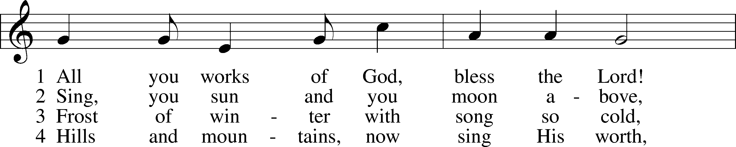
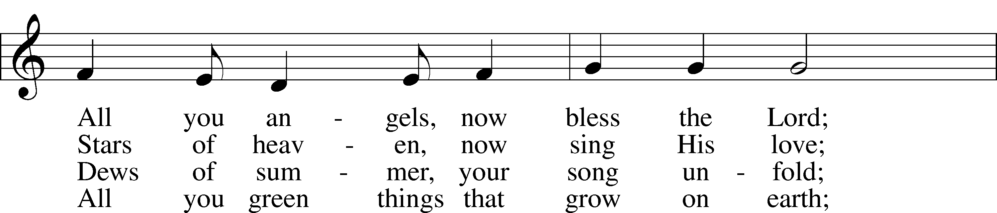
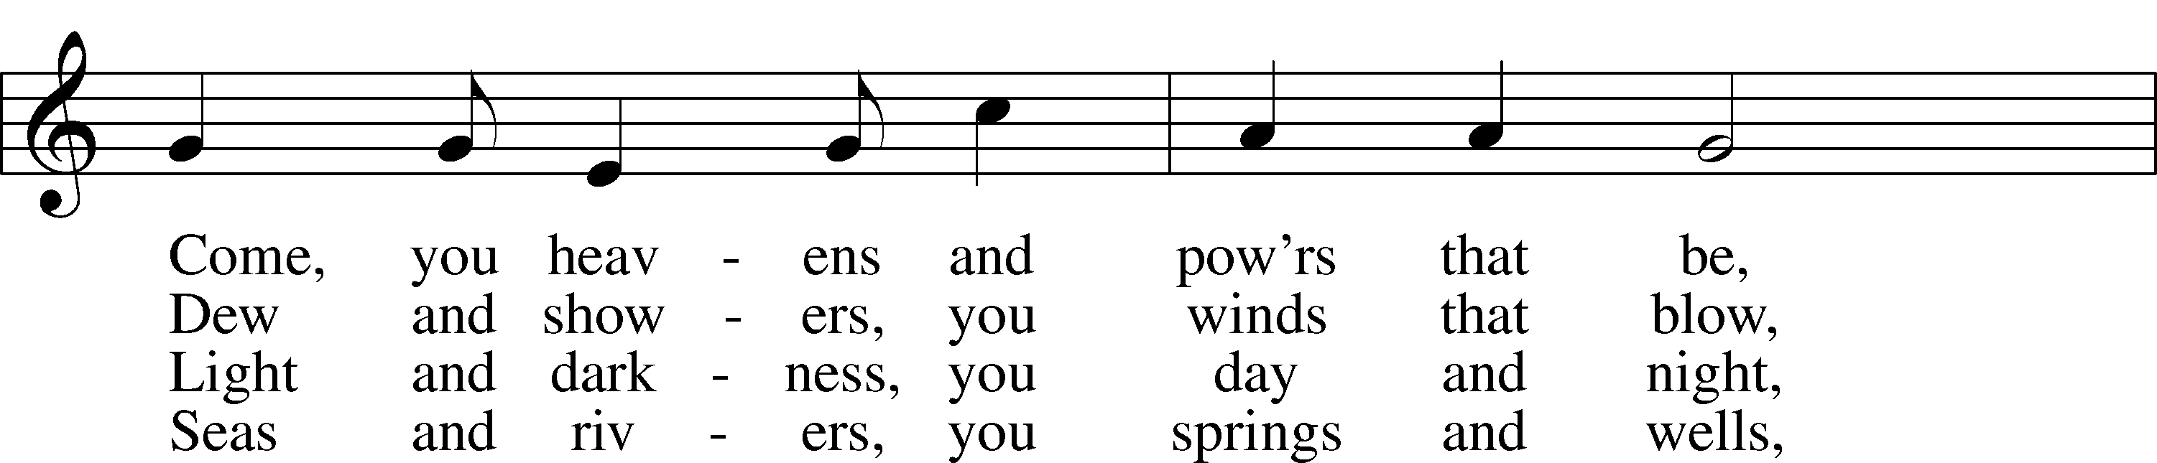
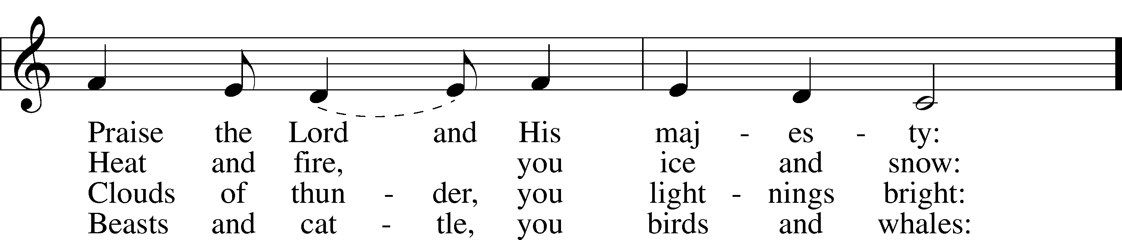
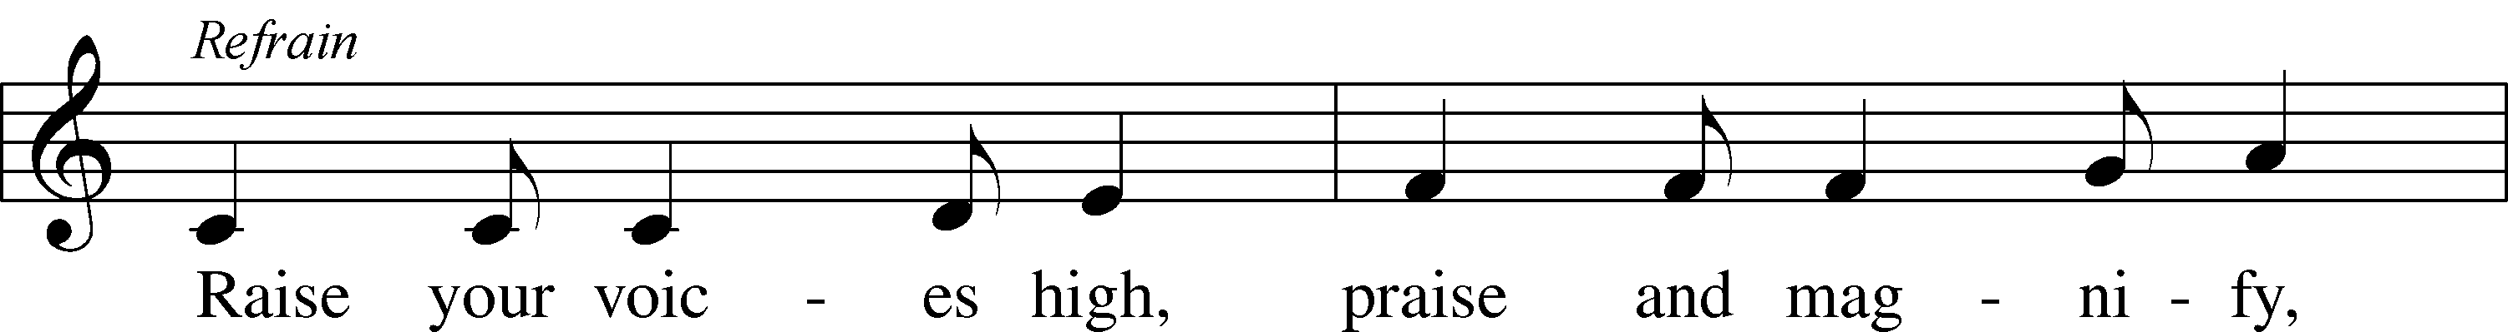
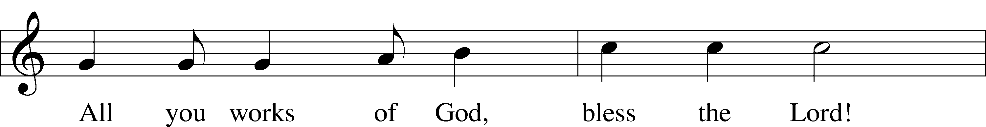
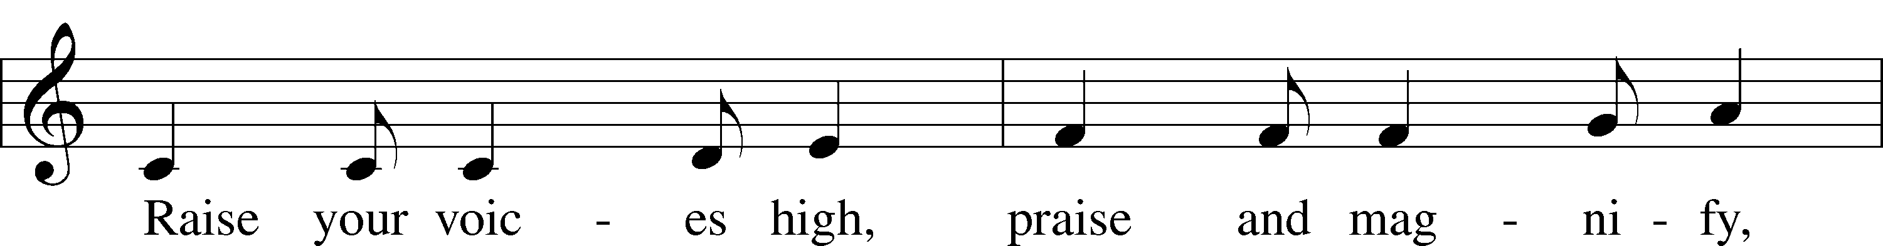
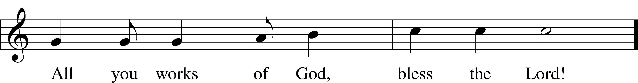

5. Come, humanity, sing along,
Sing, you people of God, a song;
Priests and servants, your Lord now bless,
Join, you spirits and souls at rest: Refrain
6. Bless the Lord, all you pure of heart;
All you humble, His praise impart;
God the Father and Son adore,
Bless the Spirit forevermore! Refrain

SERVICE OF HOLY BAPTISM                      
(Service Note: In Holy Baptism we died and were buried with Christ and were raised with Him to a new life as a child of God. In this service we receive a very physical reminder of our baptism.)

BAPTISMAL ADDRESS

P On this holiest of nights, the whole Church of our Lord Jesus Christ recalls His death and burial, rejoicing with great joy in the Gospel of His glorious and mighty resurrection from the dead. The apostle Paul says:

“Do you not know that all of us who have been baptized into Christ Jesus were baptized into His death? We were buried therefore with Him by baptism into death, in order that, just as Christ was raised from the dead by the glory of the Father, we too might walk in newness of life. For if we have been united with Him in a death like His, we shall certainly be united with Him in a resurrection like His. We know that our old self was crucified with Him in order that the body of sin might be brought to nothing, so that we would no longer be enslaved to sin. For one who has died has been set free from sin. Now if we have died with Christ, we believe that we will also live with Him. We know that Christ being raised from the dead will never die again; death no longer has dominion over Him. For the death He died He died to sin, once for all, but the life He lives He lives to God. So you also must consider yourselves dead to sin and alive to God in Christ Jesus.” Romans 6:3–11

PRAYER

P Let us pray. Almighty and eternal God, according to Your strict judgment You condemned the unbelieving world through the flood, yet according to Your great mercy You preserved believing Noah and his family, eight souls in all. You drowned hard-hearted Pharaoh and all his host in the Red Sea, yet led Your people Israel through the water on dry ground, foreshadowing this washing of Your Holy Baptism. Through the Baptism in the Jordan of Your Beloved Son, our Lord Jesus Christ, You sanctified and instituted all waters to be a blessed flood and a lavish washing away of sin.

We pray that You would behold us all according to Your boundless mercy and bless us with true faith by the Holy Spirit, that through this saving flood all sin in us which has been inherited from Adam and which we ourselves have committed since, would be drowned and die. Grant that we be kept safe and secure in the holy ark of the Christian Church, being separated from the multitude of unbelievers and serving Your name at all times with a fervent spirit and a joyful hope, so that, with all believers in Your promise, we would be declared worthy of eternal life; through Jesus Christ, our Lord.
C Amen.

RENUNCIATION

P Do you renounce the devil?
C Yes, I renounce him.

P Do you renounce all his works?
C Yes, I renounce them.

P Do you renounce all his ways?
C Yes, I renounce them.

PROFESSION OF FAITH

P Do you believe in God, the Father Almighty?
C Yes, I believe in God the Father Almighty, maker of heaven and earth.

P Do you believe in Jesus Christ, His only Son?
C Yes, I believe in Jesus Christ, His only Son, our Lord who was conceived by the Holy Spirit, born of the virgin Mary, suffered under Pontius Pilate, was crucified, died and was buried. He descended into hell. The third day He rose again from the dead. He ascended into heaven and sits at the right hand of God the Father Almighty. From thence He will come to judge the living and the dead.

P Do you believe in the Holy Spirit?
C Yes, I believe in the Holy Spirit, the Holy Christian Church, the communion of saints, the forgiveness of sins, the resurrection of the body and the life T everlasting. Amen.

REMEMBRANCE OF BAPTISM AND THE RITE OF ASPERSION

P The rite of aspersion (the sprinkling of baptismal water), referencing Psalm 51, dates to the 9th century and serves as a form of baptismal remembrance. During the singing of the baptismal hymn, water from the baptismal font will be sprinkled upon the congregation, signifying the Resurrected Life bestowed through the Word of God in Holy Baptism. You are invited to make the sign of the cross in remembrance of your baptism as you feel the sprinkling of water.

Psalm 51:1-7

P ¹Have mercy on me, O God, according to your steadfast love; according to your abundant mercy blot out my transgressions.
C ²Wash me thoroughly from my iniquity, and cleanse me from my sin!

P ³For I know my transgressions, and my sin is ever before me.
C ⁴Against you, you only, have I sinned and done what is evil in your sight, so that you may be justified in your words and blameless in your judgment.

P ⁵Behold, I was brought forth in iniquity, and in sin did my mother conceive me.
C ⁶Behold, you delight in truth in the inward being, and you teach me wisdom in the secret heart.

P ⁷Purge me with hyssop, and I shall be clean; wash me, and I shall be whiter than snow.
A Glory be to the Father and | to the Son*
and to the Holy | Spirit;
as it was in the be- | ginning,*
is now, and will be forever. | Amen.

Sit

HYMN Water, Blood and Spirit Crying
LSB 597
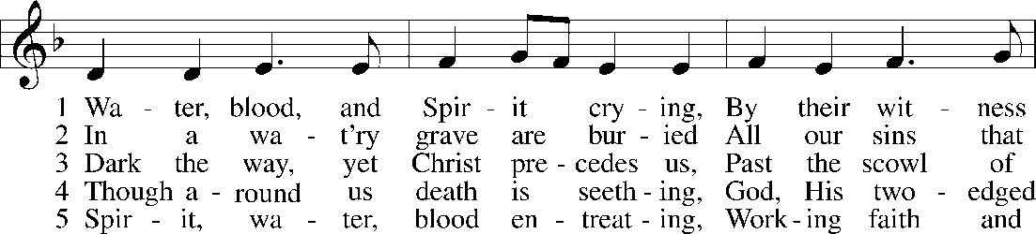

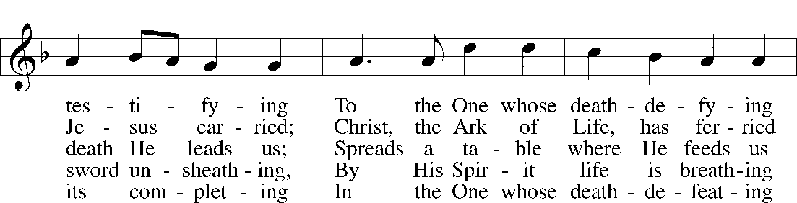

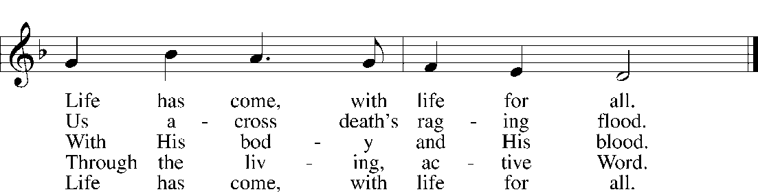

BLESSING

P The almighty God and Father of our Lord Jesus Christ, who has given you the new birth of water and of the Spirit and has forgiven you all your sins, strengthen you with His grace to life T everlasting.
C Amen.

P Peace T be with you.
C Amen.

Stand

SERVICE OF PRAYER                           
(Service Note: A Litany focusing on the Resurrection.)

LITANY OF THE RESURRECTION

P O Lord,
C have mercy.

P O Christ,
C have mercy.

P O Lord,
C have mercy.

P Lord Jesus Christ, Son of God,
C hear us.

P Paschal Lamb, who was offered for us and has taken away the sin of the world,
C have mercy on us.

P Who was crucified for our transgressions and raised for our justification,
C have mercy on us.

P Who foretold Your passion saying, “The Son of Man must be crucified and on the third day rise again,”
C have mercy on us.

P Who destroyed death by dying, and by rising to life again brought life and immortality to light,
C have mercy on us.

P Whose resurrection was first announced by an angel to the women,
C have mercy on us.

P Who appeared to Mary Magdalene and was worshiped by her,
C have mercy on us.

P Who revealed Yourself to the two disciples on the Emmaus road and made Yourself known to them in the Scriptures and in the breaking of the bread,
C have mercy on us.

P Who appeared to the disciples, bestowing on them Your peace and Your Spirit,
C have mercy on us.

P Who showed Your wounded hands and side to the apostle Thomas that he, too, might believe,
C have mercy on us.

P Who appeared to seven disciples on the Sea of Tiberias, bringing a miraculous catch of fish,
C have mercy on us.

P Who appeared to Peter and to the Twelve, to over 500 disciples, to James and to all the apostles, and to Paul on the Damascus road,
C have mercy on us.

P Who commissioned Your Church to make disciples of all nations by baptizing and teaching them,
C have mercy on us.
P By Your glorious resurrection from the dead,
C good Lord, deliver us.

P By Your victory over sin and death,
C good Lord, deliver us.

P By the majesty of Your risen body,
C good Lord, deliver us.

P We poor sinners implore You
C to hear us, Lord Jesus.

P That we may daily die and rise with You in our Baptism and walk in the freedom of Your forgiveness,
C grant us, good Lord.

P That we may set our minds on things above and not on earthly things, serving as we have been served by You,
C grant us, good Lord.

P That we may dwell with You forever in the new creation as citizens of the heavenly Jerusalem, together with all the saints,
C grant us, good Lord.

P Christ, the Lamb of God, who takes away the sin of the world,
C have mercy on us.

P Christ, the Lamb of God, who takes away the sin of the world,
C have mercy on us.

P Christ, the Lamb of God, who takes away the sin of the world,
C grant us Your peace.

P O Lord,

C have mercy.

P O Christ,

C have mercy.

P O Lord,

C have mercy. Amen.

SERVICE OF THE WORD                         
(Service Note: We now hear the first proclamation of the Resurrection. Also the Hymn of Praise with “Alleluias” return after their 45 days of silence.)

EASTER ACCLAMATION

P Alleluia! Christ is risen!
C He is risen indeed! Alleluia!

HYMN OF PRAISE
This Is the Feast

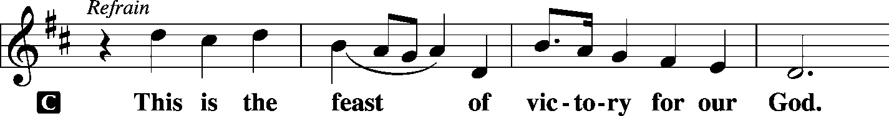
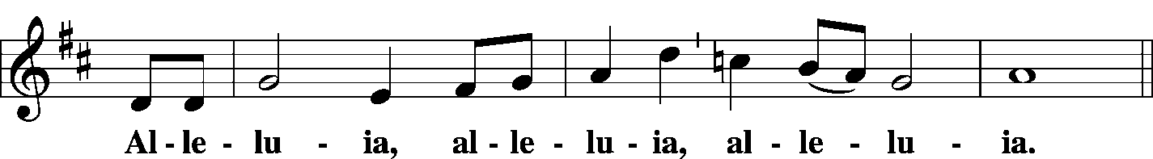
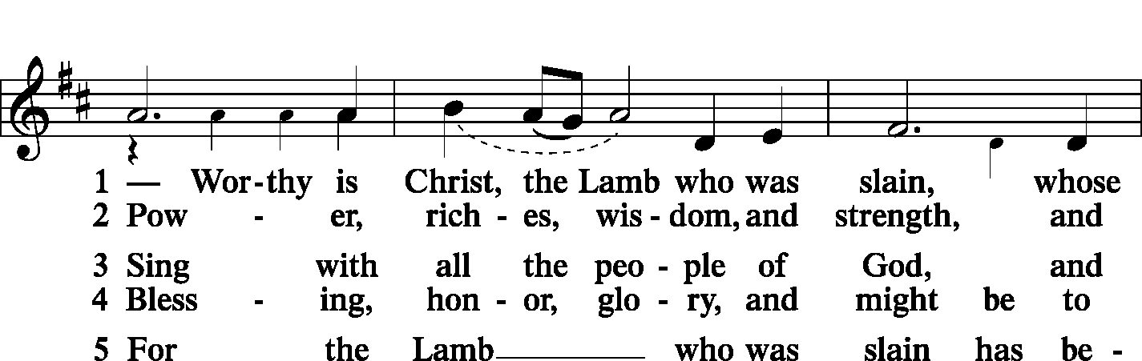
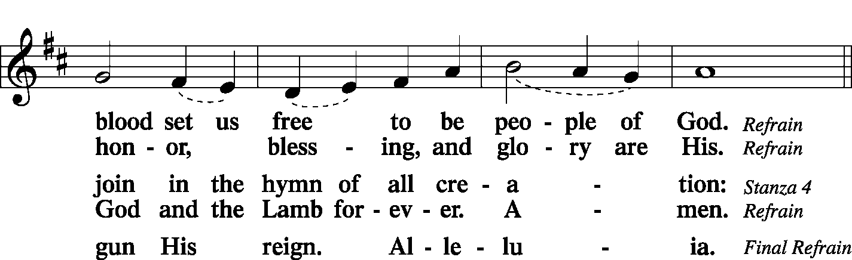
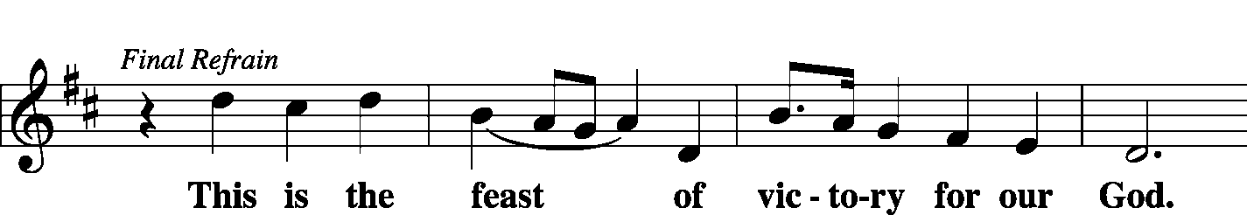
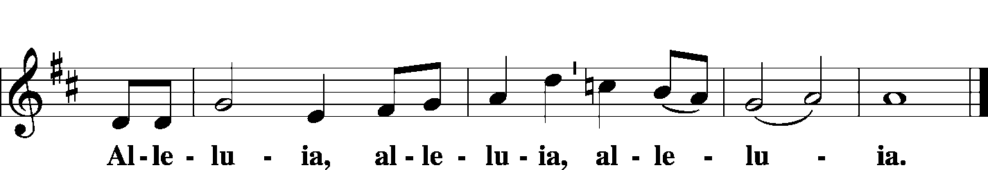

COLLECT OF THE DAY

P The Lord be with you.
C And also with you.
P Let us pray. O God, You made this most holy night to shine with the glory of the Lord’s resurrection. Preserve in us the spirit of adoption which You have given so that, made alive in body and soul, we may serve You purely; through Jesus Christ, Your Son, our Lord, who lives and reigns with You and the Holy Spirit, one God, now and forever.
C Amen.

HOLY GOSPEL Mark 16:1–8

P The Holy Gospel according to St. Mark, the sixteenth chapter.
C Glory to You, O Lord.

¹When the Sabbath was past, Mary Magdalene and Mary the mother of James and Salome bought spices, so that they might go and anoint him. ²And very early on the first day of the week, when the sun had risen, they went to the tomb. ³And they were saying to one another, “Who will roll away the stone for us from the entrance of the tomb?” ⁴And looking up, they saw that the stone had been rolled back—it was very large. ⁵And entering the tomb, they saw a young man sitting on the right side, dressed in a white robe, and they were alarmed. ⁶And he said to them, “Do not be alarmed. You seek Jesus of Nazareth, who was crucified. He has risen; he is not here. See the place where they laid him. ⁷But go, tell his disciples and Peter that he is going before you to Galilee. There you will see him, just as he told you.” ⁸And they went out and fled from the tomb, for trembling and astonishment had seized them, and they said nothing to anyone, for they were afraid.

P This is the Gospel of the Lord.
C Praise to You, O Christ.

Sit

SERMON After the End
Ezekiel 37: 1-14
Pastor Joel Schultz

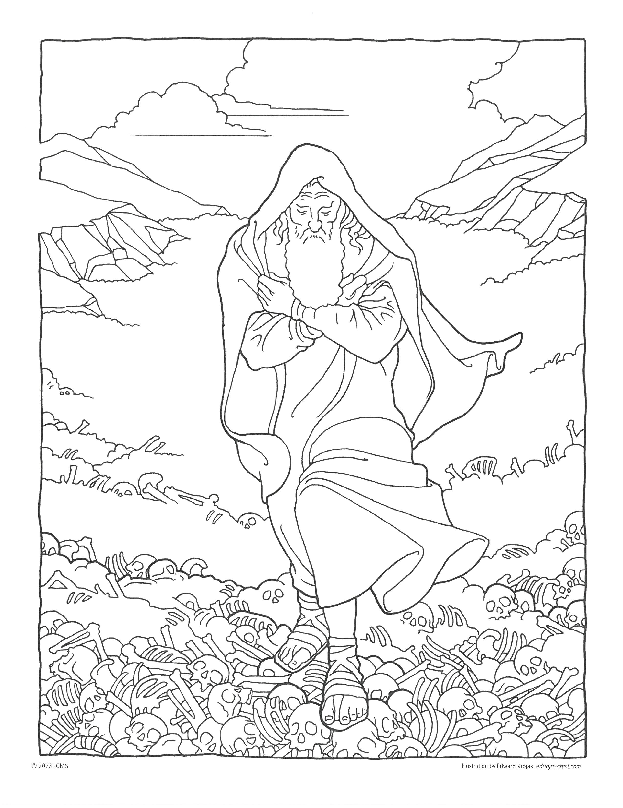
SERMON NOTES: Use this page to write notes and thoughts during the sermon. Notice the reflection question(s) at the end.
Ezekiel and the Valley of the Dry Bones

Also, the picture can be used for a different kind of note taking. Children can color the picture and show it to a pastor.

Reflect:
When does/has your sin or the sinful world made you feel dried up/lifeless?

How did God’s forgiveness, love, and mercy through His Son bring life again?

Stand

COLLECT

P Let us pray. O God, for our redemption You gave Your only-begotten Son to the death of the cross and by His glorious resurrection delivered us from the power of the enemy. Grant that all our sin may be drowned through daily repentance and that day by day we may arise to live before You in righteousness and purity forever; through Jesus Christ, our Lord, who lives and reigns with You and the Holy Spirit, one God, now and forever.
C Amen.

BENEDICAMUS/BENEDICTION

P Let us bless the Lord.
C Thanks be to God.

P The Lord bless you…and T give you peace.
C Amen.

CLOSING HYMN Christ Is Risen, Christ Is Living
LSB 479

- Christ is risen, Christ is living,
Dry your tears, be unafraid!
Death and darkness could not hold Him,
Nor the tomb in which He lay.
Do not look among the dead for
One who lives forevermore;
Tell the world that Christ is risen,
Make it known He goes before.

- If the Lord had never risen,
We’d have nothing to believe.
But His promise can be trusted:
“You will live, because I live.”
As we share the death of Adam,
So in Christ we live again;
Death has lost its sting and terror,
Christ the Lord has come to reign.
- Death has lost its old dominion,
Let the world rejoice and shout!
Christ, the firstborn of the living,
Gives us life and leads us out.
Let us thank our God, who causes
Hope to spring up from the ground;
Christ is risen, Christ is giving
Life eternal, life profound.

Acknowledgements
Vigil of Easter from Lutheran Service Book: Altar Book © 2006 Concordia Publishing House.
Divine Service, Setting One from Lutheran Service Book. Baptism Liturgy from Lutheran Service Book.
© 2006 Concordia Publishing House. Scripture quotations are from the ESV® Bible (The Holy Bible, English Standard Version®), copyright © 2001 by Crossway, a publishing ministry of Good News Publishers. Used by permission. All rights reserved

13145 S. Blackbob Road, Olathe, KS 66062
Ph: (913) 780-6023
website: www.bslcks.org
Rev. Joel Schultz, Senior Pastor
Rev. Michael Ada, Associate Pastor

Serving the Lord and Us Today:
Preaching Pastor Joel Schultz
Liturgist Pastor Mike Ada & Vicar Avery Hjulberg
Organist Lauran Delancy
Altar Guild Carol Brandt

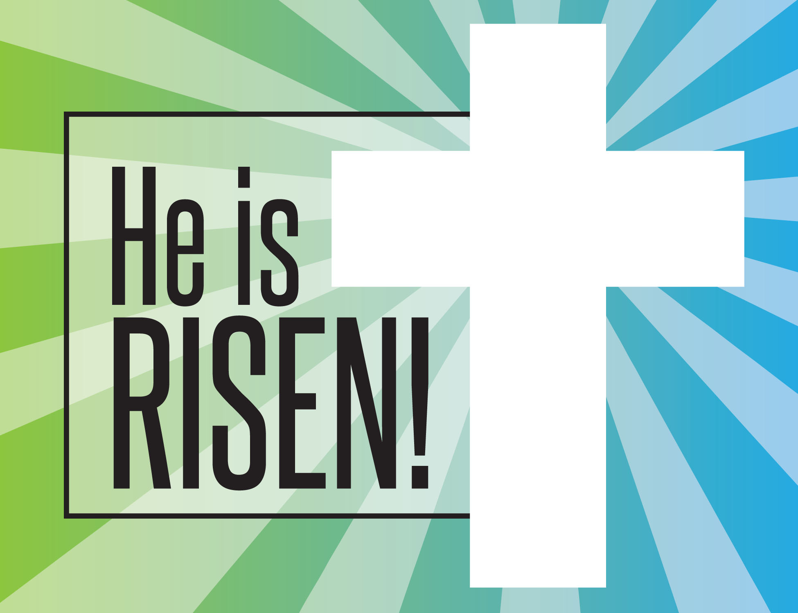

EASTER SUNDAY
6:30am Easter Sunrise Service with Holy Communion
7:30am – 10:30am – Easter Breakfast
8:00am Easter Service with Holy Communion
9:30am Easter Service with Holy Communion
11:00am Easter Service with Holy Communion

