eoday
Info As You Go

September 26, 2021

, 2020

august, 2020
20 2016

13145 S. Blackbob Road ● Olathe, KS 66062 ● 913-780-6023 ● www.bslcks.org
Connecting people to Jesus as we gather, grow, and go.

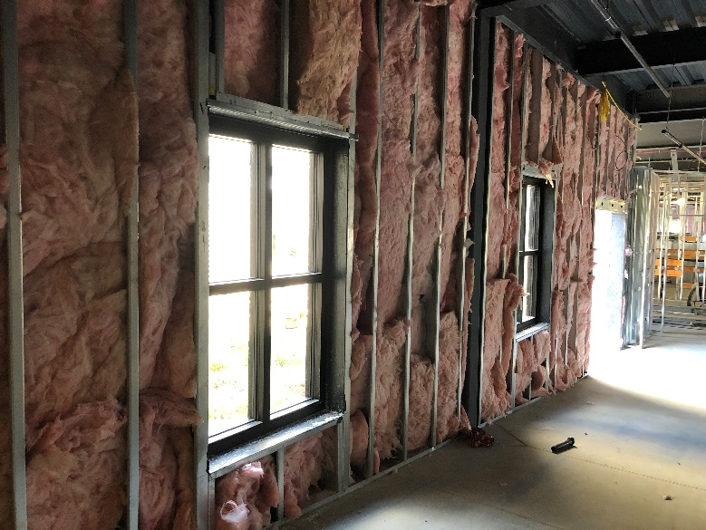
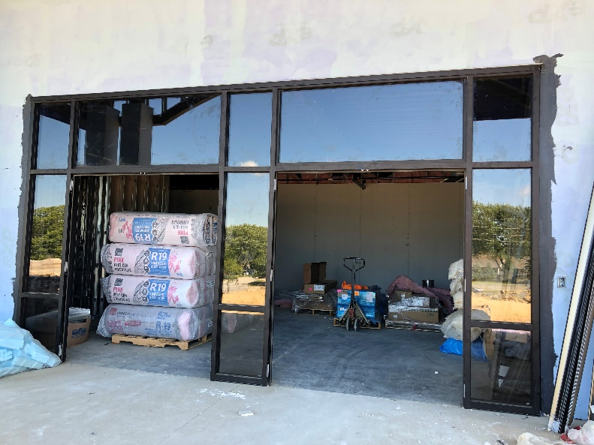

PARISH ANNOUNCEMENTS
FALL FEST
We are planning a fellowship event!
Saturday, October 16
11:00am – 3:00pm at BSLC
Bring a pot of Chili for the Chili Cook-off!
Participate in a pie eating contest!
Bingo and carnival games
Balloon animals and face painting along with a petting zoo!
Events will be outside weather permitting.
Fellowship, food, family, fun!
Don't miss it!
Look for RSVP information in the Attendance link.
Questions? Contact Jennifer Mahnken, Fellowship Chair
NURSERY NEEDS HELP OCTOBER 17TH Education hour nursery needs 1 volunteer on October 17th to be fully staffed. There will be another volunteer with you during this time. If you are able to help please contact Stephanie Gardner (email: slhenslee@gmail.com or text 913-980-5515).

OCTOBER IS PASTOR APPRECIATION MONTH
"Remember your leaders, those who spoke to you the word of God. Consider the outcome of their way of life, and imitate their faith." Hebrews 13:7

Through the year, especially during this month, please consider ways you might encourage and honor Pastor Schultz (Senior Pastor),Pastor Ada (Associate/Youth Pastor), Vicar Roll (Student Pastor), and Rev. Pingel (Visitation Pastor) for their leadership and service as we partner to “Connect People to Jesus.” Perhaps you might verbally thank them for their work among us and in the community, place a note in their mailbox, or mail them a card. Please keep them in your prayers that all that we do together here at Beautiful Savior, and through our outreach, be to the glory of God.

We also have retired Pastors worshiping with us as members. We thank them for their work in His church and continue to keep them in our prayers!

Eric Olson
Chair, Board of Elders
THURSDAY EVENING WOMEN'S BIBLE STUDY is starting a new book - Joy: The Study of Philippians by Deb Berma. This women's Bible study on the Book of Philippians, the "letter of joy," unpacks messages of contentment, confidence, humility, and hope - all found in Christ and infused with joy - in the mountaintop moments and in the mundane. You can order the study through Amazon. The group meets from 7 to 8 pm with in-person and Zoom options. Please contact Lisa Gruhn if you are interested in joining.

FAITH ALIVE We are planning for the 55 and older group, Faith Alive, to get together again for devotions and fellowship. It’s been a long time! The outdoor event will be at the church entrance on Saturday, October 9, at 4 p.m. Games of BINGO are being planned. Any “prizes” you’d like to bring, would be appreciated. Also, if you’d like, bring your lawn chair and your favorite beverage. We will provide bottles of water, sandwiches, and individual bags of snacks. Being outside and with some distancing, we are hoping all will feel comfortable to get together in this setting. (If the weather doesn’t cooperate, we will meet inside.) Anyone who is close to 50 is welcome to join us. We won’t check your ID. We are looking forward to seeing you there. If you have any questions, please contact Danny or Charlotte Hundley.

THIS WEEK IN SUNDAY SCHOOL in Today’s lesson. “The Temple Testimonies,” God fulfils His promise as Jesus is born in Bethlehem. Forty days later, in keeping with the law, the family travels to Jerusalem’s temple for Mary’s purification and Jesus’ presentation. There, they encounter Simeon, a devout Jew whose song of praise lives on in the Church today. Likewise, Anna, the aging prophetess, rejoices at the coming of the Savior.

WORSHIP RESOURCES
Lectionary Images for September 26
https://www.bslcks.org/wp-content/uploads/2021/09/2021-09-26_lectionary-images.pdf

Children’s Worship Notes September 26
https://www.bslcks.org/wp-content/uploads/2021/09/2021-09-26_childrens-worship-notes.pdf

WOMEN’S MINISTRIES

CHRISTIAN LIFE RETREAT Mark your calendars for November 12-13, 2021, as we welcome LWML Past President Patti Ross as the speaker! This women’s retreat will begin Friday evening and end Saturday afternoon. It will be held at the DoubleTree Hilton in Wichita, Kansas. Get more information by clicking on this link: November 2021 Christian Life Retreat. We hope you will consider coming!
MISSIONS
PIONEER TRAIL BACKSNACK PROGRAM
The Backsnack program at Pioneer Trail Middle School is resuming for the 2021-22 school year. Many families depend on the nutritious meals provided at schools for their children. The Backsnack program provides extra food for the weekends. This year 45 students have signed up. Beautiful Savior has participated in this program for many years. We would like to continue our support for these students this school year. Each month we will need to provide these items for each of the 45 students:
2 boxes Cereal (size that will fit in a backpack)
1 box Breakfast Bars (at least 4 count)
(any type granola bars, protein bars, etc.)
1 - 4-pack fruit cups
(Larger count packages of bars and fruit cups are okay.)
There are more students needing this additional food this year. Please consider donating what you can or “adopt” a student by providing food each month. Any questions, contact Charlotte Hundley.

PRESCHOOL NEWS

PRESCHOOL CHILDREN were busy this week with lots of fun themes. Our different classes explored the themes of the color green, apples, community helpers, nursery rhymes, and the story of Abraham and Sarah having a son named Isaac. Vicar told the children in chapel that God kept his promise that Abraham would have descendants as many as the stars in the sky. We sang “Father Abraham” together while we marched! Next week we have Picture Days on Monday and Tuesday with Lil’ Angel’s Photographers.

COMMUNITY NEWS

FOREIGN EXCHANGE STUDENT A sophomore boy from South Korea, now attending Lutheran High School, is in need of a host family for the remainder of this school year. Kevin Kang is friendly, thoughtful, warm, caring, well-behaved, mature, and positive. He began his US educational journey as an 8th grader at Calvary Lutheran School. Some of his favorite activities include fishing and playing soccer, basketball, and baseball. He makes friends easily and likes to laugh a lot. His favorite subjects are Physical Education and Mathematics. What better way to discover the world than to do so by welcoming an exchange student into your home. Experience the convenience of learning in your living room. In return, share America with an exchange student and make a difference globally! If interested, please call the LHS school office at 816-241-5478 or email Paula Meier at pmeier@lhskc.com.

LUTHERAN HIGH SCHOOL'S THRIFT STORE The Lost and Found Thrift Store in Grandview desperately needs some volunteers to work 2-4 hours on Tuesdays and Thursdays every week to organize departments, put up pictures, and tag clothing to be hung up. We would love to have you come out and volunteer in the store's relaxed and upbeat environment. Call Lohren Meier at the store 816-673-1099 or on his cell phone 816-309-7856 to sign up. The store is located at 12104 Blue Ridge Blvd in Grandview. We are open Tuesdays-Fridays 10am-5pm and Saturdays 10am-3pm.

STEWARDSHIP CORNER In the Apostle Paul’s letter to the church in Corinth, he uses the human body as an analogy to help us understand our different roles in God’s kingdom (1 Corinthians 12). Just as God gives the human body many different parts that work together for the good of the body, we, as God’s people, work together to help those in need and to extend His kingdom. We are not all expected or even needed to do the same things. But each of us has been gifted and blessed to have a role. May God help us all discover our roles and find joy in serving in that role.

STEWARDSHIP INVOLVES ALL OF OUR MONEY, NOT JUST WHAT WE GIVE TO GOD THROUGH OUR CHURCHES.
“The silver is Mine, and the gold is Mine, declares the Lord of hosts” (Haggai 2:8).
CALENDAR:
Sunday, September 26
8:00am - Worship w/ Comm. with live-stream
9:30am – Education Hour live and streamed
10:45am – Worship w/ Communion
3:00pm – Laudate Ringers until 3:45pm
4:00pm – Youth Choir until 4:45pm
5:00pm – Beata Handbells until 5:45pm
6:00pm – Evening worship w/ Communion (masks)
Monday, September 27
Preschool pictures – Fellowship Room until 1:00pm
8:15am – Preschool
12:15pm – Preschool
6:00pm – Saving Grace
Tuesday, September 28
Preschool pictures – Fellowship Room until noon
8:15am – Preschool
9:00am – Organist Practice
12:15pm – Preschool
Wednesday, September 29
6:30am – Men’s Bible Study until 7:30am
8:15am – Preschool
9:00am – Organist Practice
10:00am - LifeLight
12:15pm – Preschool
6:00pm – Chimes Choir until 6:30pm
6:00pm – Confirmation
6:00pm – Pre-Confirmation
6:30pm – Adult Bells until 7:30
7:30pm – Adult Choir until 8:30
Thursday. September 30
8:15am – Preschool
9:30am – Women’s Bible Study via Zoom
12:15pm – Preschool
6:00pm - LifeLight
7:30pm – Women’s Bible Study
Friday, October 1
8:15am – Preschool
12:15pm – Preschool
Saturday, October 2
8:30am – Altar Guild Prep until 9:30am
Sunday, October 3
8:00am – Worship w/ Comm. & live streamed
9:30am – Education Hour & Live streamed
10:45am – Worship w/Communion
3:00pm – Laudate Ringers until 3:45
4:00pm – Youth Choir until 4:45
5:00pm – Beata Handbells until 5:45
6:00pm – Evening worship w/ Communion (masks)

Birthdays:
Sept. 26 Greg Enserro, Mark Horrigan,
Samantha Ronsick, Sophia Teply
Sept. 27 Jonathan Batsch, Jacob Vaughn
Sept. 28 Carolyn Clarke, Carol Smith,
Jennifer Bertels, Hannah Behrman
Sept. 29 Alisyn Taege
Sept. 30 Alexandria Booth
Oct. 1 Riley Olson
Oct. 2 Eden Keefe, Hadley Werling

Anniversaries
Sept. 26 Mike & Wanda Freeman
Darren & Loran Wagner
Sept. 27 Jeff & Cheryl Kerns
Sept. 28 Chad & Nancy Ronsick
Sept. 30 Shannon & Kristi Buckendahl
Garry & Donna Harris

Our Worship for 9-19-21
8:00am 155
10:45am 124
6:00pm 19
You-Tube streaming 67
Total 365

Offerings $15,801.26

Sunday $144.25

Sunday School Attendance (in person) 102
Children 65

Trusting Hearts $2,600.00
Offerings do not include any Electronic Contributions.

September 26, 2021
Visitors and Members - please register
your attendance

